Summary
We analyzed WeChat v8.0.23 on Android and iOS as part of our ongoing work analyzing popular mobile and desktop apps for security and privacy issues. We found that WeChat’s proprietary network encryption protocol is not up-to-par with modern network encryption protocols, such as TLS or QUIC+TLS. For instance, the protocol is not forward-secret and may be susceptible to replay attacks. We plan on publishing a documentation of the MMTLS network encryption protocol, as well as the “Business-layer” encryption protocol, and strongly suggest that WeChat, which is responsible for the network security of over 1 billion users, switch to a strong and performant encryption protocol like TLS or QUIC+TLS.
Below, we detail our understanding of WeChat’s network request encryption systems, as well as our security and privacy analyses of the systems.

1. WeChat Encryption Protocol Description
The sum of WeChat's network encryption system is disjoint and complex. WeChat network requests are often encrypted twice, with distinctly negotiated sets of keys and different cryptographic primitives. To simplify the explanation, we differentiate between these two cryptosystems as MMTLS Encryption and Business Encryption. This naming scheme is derived from WeChat's blog post, which describes MMTLS as an encryption protocol designed to replace the original “business-layer” (业务层) encryption protocol. However, we find that requests are encrypted first with this “business-layer” encryption, and then with MMTLS. The “inner” layer encryption can be understood as this Business Encryption, and the “outer” layer can be understood as “MMTLS”.

The type of encryption, authentication, and keys used by Business Encryption, and even the transport, i.e. shortlink or longlink (as described in Section 1A), will often change depending on the specific network request type. Various internal services within WeChat seem to exclusively support different types of Business Encryption.

Finally, the keys and encryption used by Business Encryption also changes depending on if the user is logged-in or logged-out. We summarize these details in Table TKTK.

 | Key derivation | Encryption | Library
MMTLS Encryption (longlink) | Diffie-Hellman (DH) | AES-GCM with tag | libwechatnetwork.so
MMTLS Encryption (shortlink) | DH with resumption | AES-GCM with tag | libwechatnetwork.so
Business Encryption (logged-out) | Static DH | AES-GCM with tag | libwechatmm.so
Business Encryption (logged-in) | Fixed key from server | AES-CBC with checksum | libMMProtocalJNI.so

In the subsequent sections, we describe important details of each cryptosystem as a whole. Additional details can be found in Sections 1B and 1C.

1A. Network Transports
WeChat network requests can occur over one of two network transports, dubbed shortlink and longlink by WeChat logs.

For the longlink transport, the client opens a long-lived TCP connection and sends MMTLS packets directly over the TCP connection. We observed the TCP port used by longlink to be either 443 and 8080. Certain WeChat requests prefer to be sent over longlink. For instance, when the user sends a WeChat message, a longlink transport message is sent. The TCP connection used for longlink messages is generally quite long-lived, opened on client startup and kept alive using periodic heartbeat messages containing no-op data. In their blogpost, WeChat developers note that longlink connectivity is not guaranteed as some middleboxes will drop TCP packets containing non-standard payloads.

The fallback, and the default for the bulk of WeChat data, is the shortlink transport. MMTLS data are sent in the body section of HTTP POST request/response. The HTTP path identifies the MMTLS session, since there may be more than one simultaneous MMTLS session. The shortlink transport connection closes after the client receives a response.

Since shortlink itself only supports a single round-trip of data (HTTP POST request and response), this necessitates the use of either a fixed encryption key, static Diffie-Hellman, or some form of “session resumption” for all data encrypted and sent in the body of shortlink, since a standard Diffie-Hellman handshake would take one additional round-trip. We observe “session resumption” used in the MMTLS Encryption layer, static Diffie-Hellman used in Business Encryption when the user is logged-out, and a per-user fixed static key used in Business Encryption when the user is logged-in.

1B. MMTLS Encryption
Generally, the MMTLS Encryption layer is modeled heavily after TLS and uses similar structures, primitives, and terminology, such as Records and Extensions. We use the same terms of art.

1B1. Handshake
The MMTLS Encryption layer, like TLS, performs an elliptic-curve Diffie-Hellman handshake to establish shared key material with the server. The app sends a ClientHello containing the client's public key and ClientRandom. In response, the server sends a ServerHello containing the server's public key share and ServerRandom, then the server's certificate and a resumption ticket, both encrypted with a key derived from the shared secret.

Once the shared secret is derived, further data records can be sent via TCP if the connection is over longlink. Future shortlink connections will use the resumption ticket, and use the same shared secret to derive future keys via HKDF, a key derivation function. We note that the initial shared secrets established by longlink and shortlink handshakes differ from each other.

When the application is opened, the client first simultaneously sends a standard ClientHello packet over both the shortlink and longlink. The first connection to complete the handshake is then used to perform the first WeChat request. If the user is logged-in, this includes establishing key material for the Business Encryption process.

1B2. Encryption
The MMTLS Encryption layer encrypts data and calculates a message authentication code (MAC) using AES-GCM. Keys and IVs are derived via HKDF from the shared secret for a particular session. The IV is incremented by the number of Records previously encrypted with the same key. OpenSSL bindings are used for all the above.

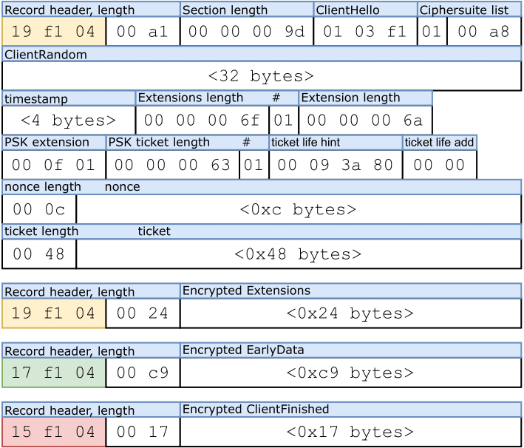
Figure 1. Annotated sample of an MMTLS Encryption Session Resumption ClientHello packet, as collected by tcpdump. This packet was in the Request body of a POST request, so it was over the shortlink transport. The “Encrypted Earlydata” contains the encrypted Inner Encryption payload.

1C. Inner Encryption
WeChat requests are generally double-encrypted. This section describes the Business Encryption layer. We note that the key material and logic used in this section is entirely separate from that used in the MMTLS Encryption layer.

In our testing, Business Encryption was consistent between all logged-in requests and between all logged-out requests, so we chose this dichotomy to present our findings.

1C1. Internal network request metadata.
Internally, each WeChat network request is referred to as a Scene. In general, each Scene defines an internal cgi-bin URL and a unique request_type integer. For instance, the first request the app makes when logged-in is named the AutoAuth Scene, with internal URL /cgi-bin/micromsg-bin/autoauth and a request_type of 721.

We note that certain Scene also prefer different types of encryption, ranging from the default AES-CBC, to encryption with an RSA public key, to no encryption at all. One scheme we noticed, for instance, was that cgi-bin URLs ending with rsa were configured to use encryption with a public RSA key. Thus we conclude that certain internal web-services within WeChat were configured to support only specific types of encryption. However, through our testing, we only observed requests encrypted in the following manner, as described in Sections 1C2 and 1C3.

1C2. Encryption when logged-out.
When logged-out, the Business Encryption layer essentially uses a key generated from static Diffie-Hellman to encrypt all requests. The Diffie-Hellman key is generated from a static server key and a fresh client key each time, which means there is no key management on the client-side. The app is shipped with a static server public key, and generates a new client keypair for each new request. Then, the client generates the shared secret from the server public key and their newly generated private key. The shared secret is then used to extract a key and IV via HKDF. Encryption is performed via AES-GCM. The ciphertext and tag are sent alongside the generated client public key so the server can also calculate the shared secret and decrypt data.

The server responds with a fresh, newly generated public key as well as a ciphertext. The client can then decrypt the server response with a new shared secret, ecdh_secret generated from their private key and the public key provided by the server.

1C3. Encryption when logged-in.
If the user is logged-in, the cryptosystem is different after the first request. The first outgoing request is the same as in the logged-out case. It is encrypted with a key derived from static Diffie-Hellman. The server also sends a response, and a new public key. The client then generates a new ecdh_secret from this data. However, on decrypting the server response, the client also receives a session_key that is sent by the server. This provided session_key is then used for all future encryption and decryption, and there is no more Diffie-Hellman ratcheting. The aforementioned ecdh_secret is only used to generate a checksum for future requests (described in the next paragraph), and not used for encryption.

When logged-in, the Business Encryption layer uses AES-CBC with PKCS7 padding. The session_key is used as both the key and IV. Business Encryption also generates and appends a checksum. Below, U is the user's WeChat ID, k_{ecdh} is ecdh_secret, p is the plaintext, and l_{p} is its length:

S = adler32(md5(U | k_{ecdh} | l_{p} ) | p)

Within the WeChat code, this checksum is referred to as a Signature, calculated by a function named genSignature. However, as we describe in the next section,, the checksum is forgeable and thus has no cryptographic properties.

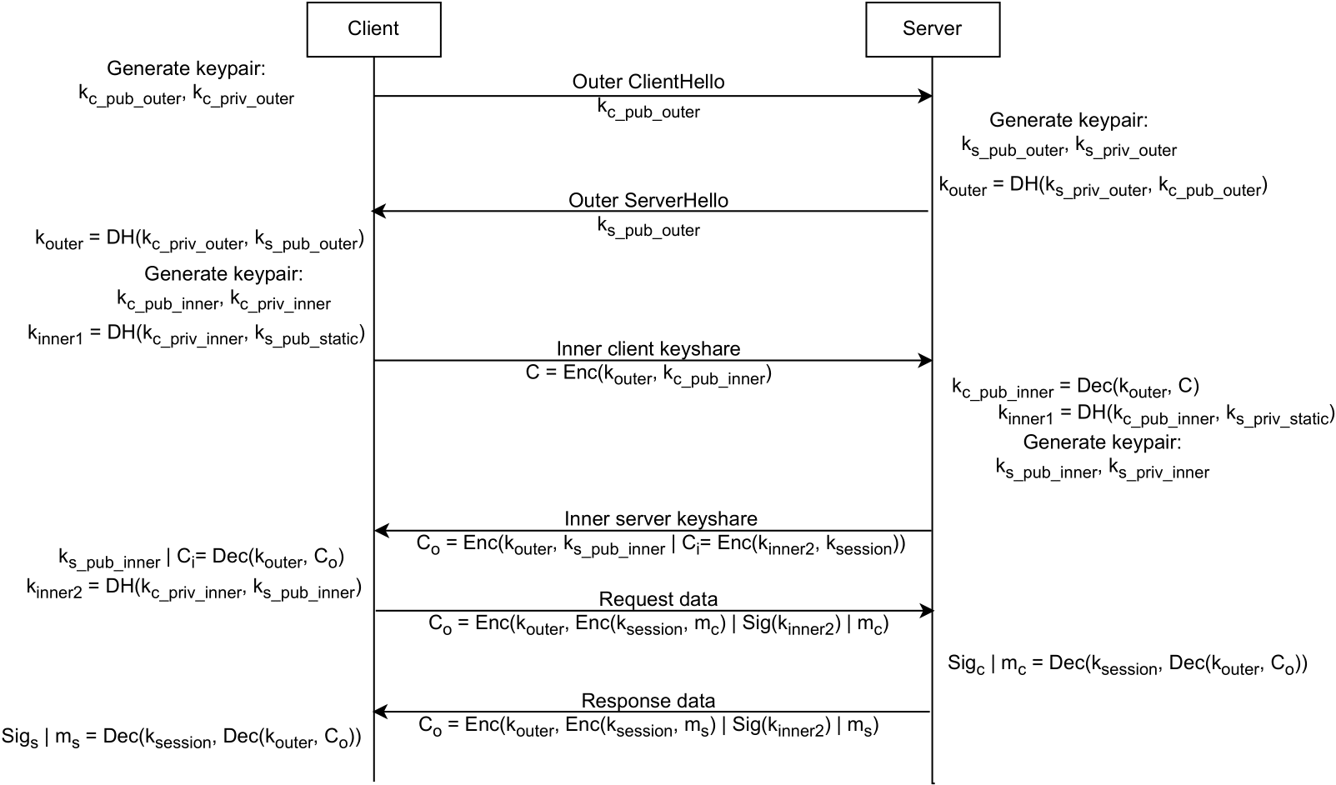

Figure 2. WeChat network encryption handshake flow when logged-in, showing interaction between MMTLS Encryption and Business Encryption. The MMTLS Encryption handshake occurs first, to establish the k_{outer} key, then the key agreement occurs for the Business Encryption. k_{session}, the encryption key for Business Encryption is generated by the server via a process that is unknown to us. k_{s_pub_static} is pinned in the application beforehands.

2. WeChat Network Security Analysis and Recommendations
In this section, we discuss our concerns with the design and implementation of these cryptosystems which govern the network security of over one billion individuals. Our point of comparison is TLS.

Limited forward secrecy. Static Diffie-Hellman and non-forward-secret cryptographic constructions are prevalent throughout all of WeChat's cryptosystems. This detail makes these cryptosystems more similar to ETS/eTLS (“enterprise TLS”) and other controversial proposed modifications to TLS 1.3 that would weaken its forward secrecy. These proposals are generally driven by data centers, enterprises, or other financial institutions, who wish to retain the ability to decrypt traffic at network egress points. However, this proposal was controversial as forward secrecy is generally considered a core feature of TLS, and those standardizing the protocol wanted to prevent network traffic monitoring, not encourage it. And in any case, the proposals are not motivated by the use case of a global communications platform like WeChat.

Replay attacks. We find that much of WeChat's MMTLS Encryption system should be susceptible to replay attacks unless there are additional replay protections built into the protocol that we could not detect. This is confirmed by WeChat's blog post which acknowledges this issue and mentions a nonspecific replay protection that works within some fixed epoch. The blog post also insists that further replay protection should be implemented at the application layer. We attempted to replay Moments posts and WeChat messages, but did not succeed. However, the solutions hinted at in the blog post seem non-comprehensive, and the possibility of replay attacks remains.

Deprecated OpenSSL internal APIs. All of WeChat's cryptosystems use OpenSSL bindings in native code. In addition, after matching up the OpenSSL functions from the decompiled code, we find that many of the functions used are now deprecated and no longer being supported. OpenSSL's internal APIs are famously difficult to use correctly and have led to security issues in the past.

2A. Issues with Business Encryption
In this section, we discuss non-standard design decisions implemented in the Inner Encryption layer and possible concerns with this cryptosystem. We note that since it is wrapped in MMTLS Encryption, which preserves confidentiality and integrity, there is not an obvious way to exploit these issues.

Forgeable genSignature check.
After decrypting the session_key, the ecdh_secret is only used in generating this checksum data. We recall that the checksum is generated as follows:

S = adler32(md5(U | k_{ecdh} | l_{p} ) | p)

We can subtract and add from this adler32 checksum by solving for a system of equations when the message is short. Thus, without knowledge of k_{ecdh}, we can easily generate the following valid checksum S’ for short p’ that are the same length as p:

S’ = S - adler32(p) + adler32(p’) % 2³²

This requires a known plaintext p. Many messages sent by WeChat are predictable and identical, so there are many such known plaintexts. While the original purpose of the genSignature checksum is unclear, this checksum is also the only apparent use of k_{ecdh}, or ecdh_secret when the user is logged-in.

AES-CBC mode without integrity or authenticity.
There is no other MAC or MAC-like data included in the Inner Encryption layer, so block cipher mode gadgets may be viable within the constraints of genSignature's forgeability. In extreme cases, these can create side-channels that lead to plaintext exfiltration, as with PGP and S/MIME implementations.

Finally, since AES-CBC is used alongside PKCS7 padding, this construction could be susceptible to an AES-CBC padding oracle, leading to recovery of encrypted plaintext. In 2023, another custom cryptography scheme using the same construction, also developed by a Tencent company, was found susceptible to a CBC padding oracle attack.

Key, IV re-use.
Re-using the key as the IV for AES-CBC, as well as re-using that key for all encryption in a given session (i.e. the length of time that the user has WeChat open) introduces privacy leaks. Two plaintexts that are identical will encrypt to the same ciphertext. In addition, two plaintexts with identical N block-length prefixes will encrypt to the same first N ciphertext blocks.

Selection of encryption key by server.
For modern transport protocols, it is highly unconventional for one party to unilaterally choose a session encryption key. In fact, we note that the encryption key generated by the server exclusively uses printable ASCII characters. Thus, even though the key is 128 bits long, the entropy of this key is only around 100 bits.

Uncertain key lifetime.
In our testing, we did not observe session_key, the encryption key chosen by the server, change or roll over. All encryption in the Inner Encryption layer is performed with this key. The client does not receive a new key until they close and restart the WeChat application. There is no forward secrecy, and there is larger surface area for privacy leaks due to IV re-use.

2B. Issues with MMTLS Encryption
Deterministic IV.
The MMTLS encryption process generates a single IV once per connection. Then, it increments the IV for each subsequent record encrypted in that connection. Generally, NIST recommends not using a wholly deterministic derivation for IVs in AES-GCM since it is easy to accidentally re-use IVs. In the case of AES-GCM, reuse of the (key, IV) tuple is catastrophic as it allows key recovery from the AES-GCM authentication tags.

In addition, Bellare and Tackmann have shown that the use of a deterministic IV can make it possible for a powerful adversary to brute-force a (key, IV) combination. This type of attack applies to powerful adversaries, if the crypto system is deployed to a very large (i.e. the size of the Internet) pool of (key, IV) combinations being chosen. Since WeChat has over 1 billion daily active users, this order of magnitude puts this attack within the realm of feasibility.

Limited forward secrecy in practice.
MMTLS liberally uses the equivalent of a controversial TLS 1.3 feature called “0-RTT resumption,” which allows you to resume a previous TLS connection with zero extra round trips (0-RTT). In order to do this, clients receive long-lived keys called “pre-shared keys.” They have a much longer lifetime, thereby allowing clients to begin encrypting data even without needing to complete a new handshake. All data sent via shortlink transport is thus encrypted with a pre-shared key.

In practice, this means that forward secrecy is limited to each WeChat session; i.e. the keys are rotated when the user closes and re-opens the application.

3. Recommendations and Performance Considerations
In this post from 2016, WeChat developers note that they wished to upgrade their encryption, but the addition of another round-trip for the TLS 1.2 handshake would significantly degrade WeChat network performance, as the application relies on many short bursts of communication. At that time, TLS 1.3 was not yet an RFC (though session resumption extensions were available for TLS 1.2), so they opted to “roll their own” and incorporate TLS 1.3's session resumption model into MMTLS.

This issue of performing an extra round-trip for a handshake has been a perennial issue for application developers around the world. The TCP and TLS handshake each require a single round-trip, meaning each new data packet sent requires two round-trips. Today, TLS-over-QUIC combines the transport-layer and encryption-layer handshakes, requiring only a single handshake. QUIC was developed for this express purpose, and can provide both strong, forward-secret encryption, while halving the number of round-trips needed for secure communication. We also note that WeChat seems to already use QUIC for some large file downloads. Our recommendation would be for WeChat to migrate entirely to a standard TLS or QUIC+TLS implementation.

There is also the issue of client-side performance, in addition to network performance. Since WeChat's encryption scheme performs two layers of encryption per request, the client is performing double the work to encrypt data than if WeChat used a single standardized cryptosystem.

